**Ideation Phase**

**Brainstorm & Idea Prioritization Template**

|  |  |
| --- | --- |
| Date | 19 September 2023 |
| Team ID | NM2023TMID08200 |
| Project Name | iRevolution: A Data-driven Exploration of Apple's iPhone Impact in India |
| Maximum Marks | 4 Marks |

**Brainstorm & Idea Prioritization Template:**

Analyzing the growth of iPhone sales in India over the years and its impact on the overall smartphone market.

Investigating the impact of iPhone usage on digital literacy, internet penetration, and access to information in rural areas of India

Reference: <https://www.mural.co/templates/empathy-map-canvas>

**Step-1: Team Gathering, Collaboration and Select the Problem Statement**

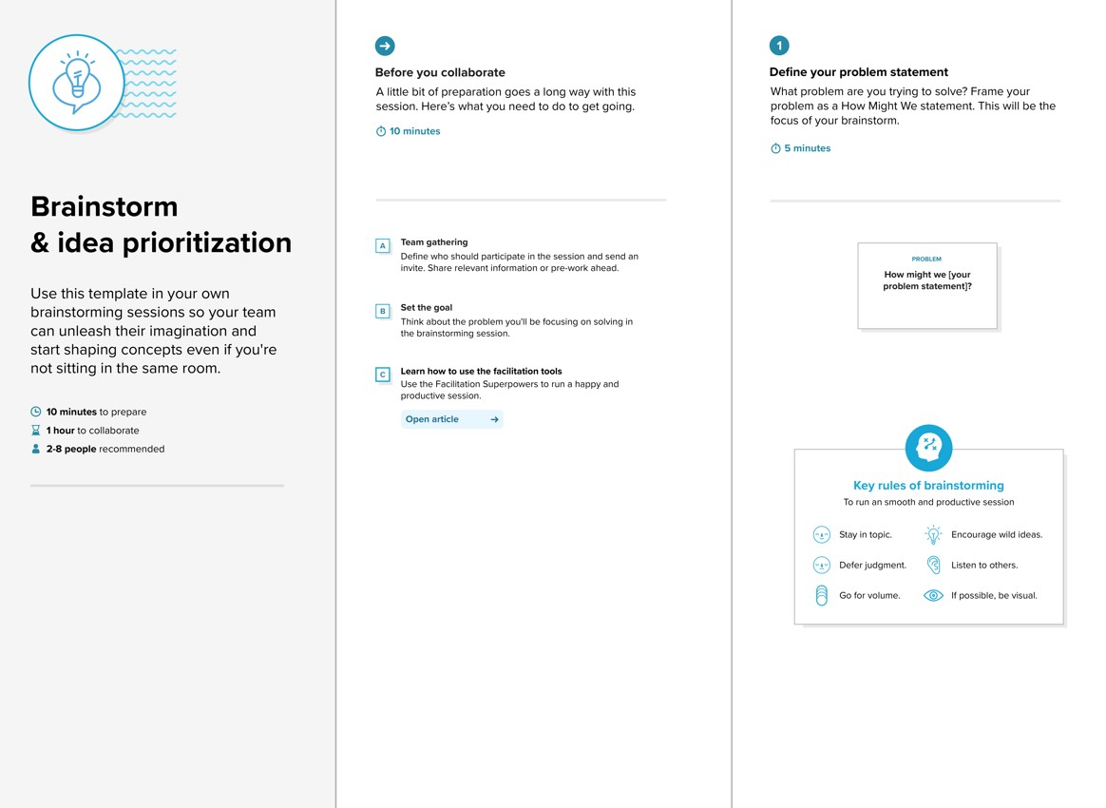

**Step-2: Brainstorm, Idea Listing and Grouping**

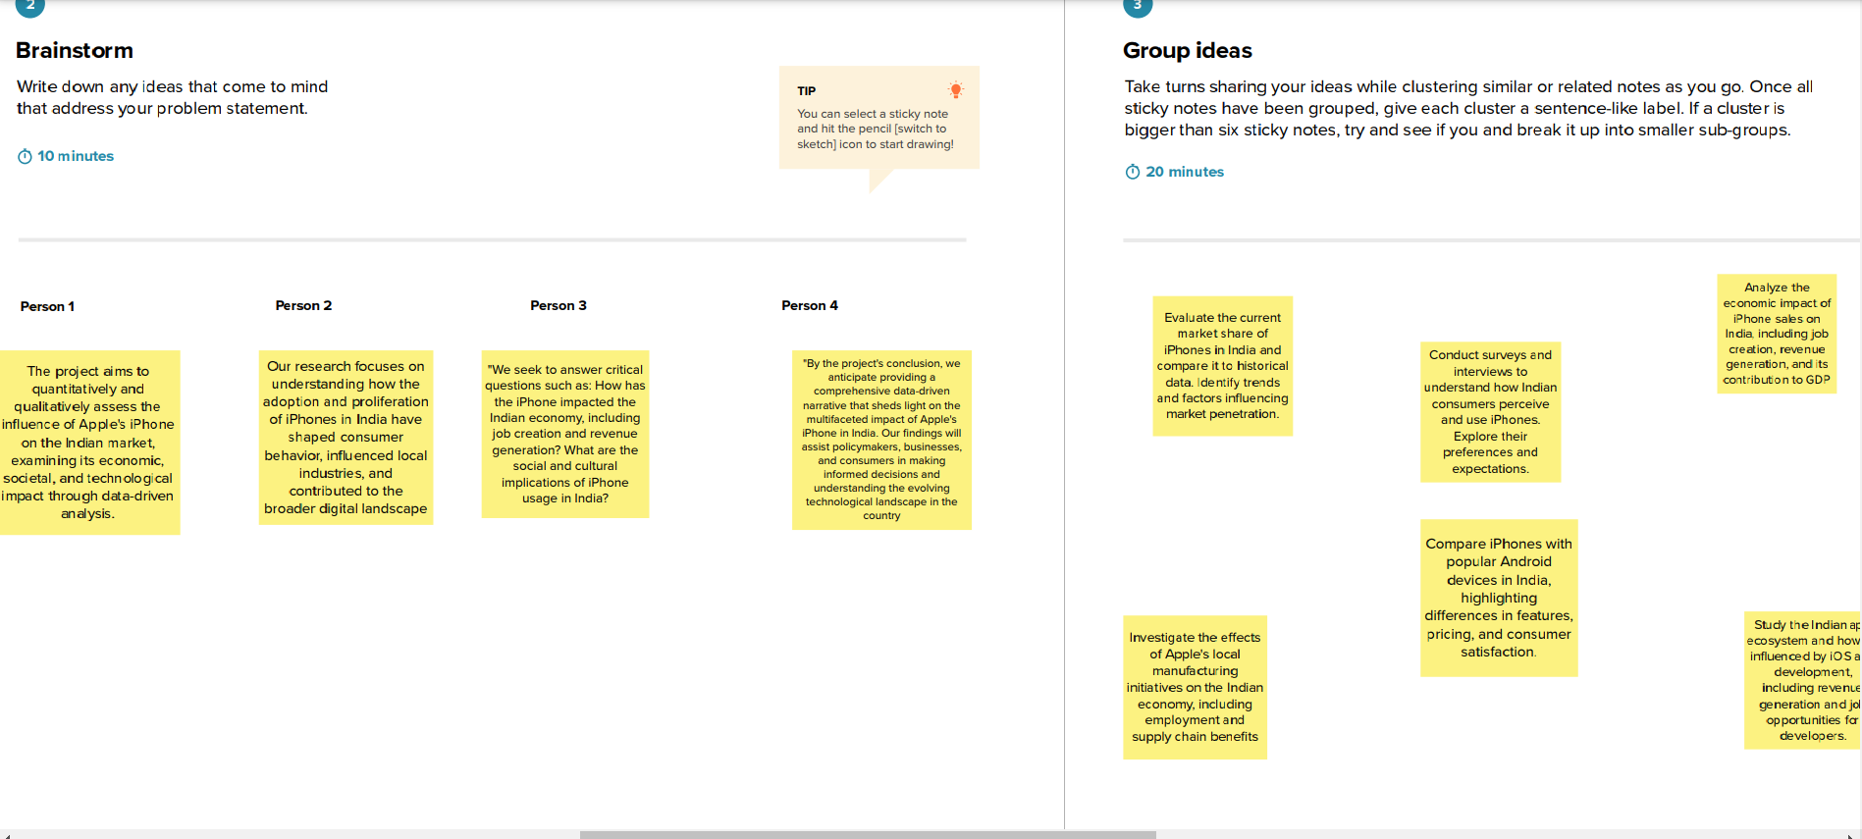

**Step-3: Idea Prioritization**

